d
Prjoect initiation Doccument
Cyber Security Awareness Game
Samuel Honeybone

Contents
Introduction 2
Business Case 2
Business Need 2
Business Objectives 2
Project Objectives 3
Smart Targets 3
Initial Scope 4
Must have 4
Should have 4
Could have 5
Won’t have 5
Method of approach 5
Initial project plan 5
Project plan 5
Control plan 6
Communication plan 7
Legal, Ethical, Social and Professional 7
Initial Severity list 7
Initial Quality Plan 9
Gantt Chart 10
References 12

Introduction
When looking at cyber security in 2025 most attacks occur due to human errors, things such as social engineering to steal credentials or just users falling for simple phishing emails. (Team, 2025) Although usually security experts put everything in place that they can to prevent bad actors gaining control over the network they can’t physically prevent human errors from occurring. This is usually prevented through training and tests such as fake phishing emails to see who will fall for it. This clearly isn’t working; this project will aim to provide a game style training method which will put users in different situations to see how they will respond and teach them the consequences and correct responses in a more engaging way than the current read a document and then answer some questions method. (Briscoe, 2025)

Business Case

Business Need
Currently cyber security training for jobs is boring and doesn’t properly engage the people Involved. (Briscoe, 2025) (SUNNYVALE, 2024) It is currently done in a very standard read the information and then answer some questions on that information format, this means that when people are doing it, they don’t take in the information provided beyond answering the one-time quiz. This can lead to mistakes on the job and people not really being informed on the correct cyber protocols.

Business Objectives
To provide a platform in a way that:
- Can assist with training staff in basic cyber security protocols, such as the importance of strong passwords and the ability to spot phishing emails
- Allow people to have fun while playing a game
- Teach people the potential consequences of not following the correct cyber protocols
- Provide a different type of cyber training to hopefully reduce the number of cyber-attacks due to human error and social engineering

Project Objectives
The objective of this project is to provide a game style security training platform where users will play through different scenarios, such as someone asking them to hold the door open for them or receiving a phishing email, they will then be provided with a set of options such as holding the door open, or asking to see their ID before letting them in. depending on the choice they will either pass and have a short explanation of why that was the correct answer or fail the test and the consequences and correct response in that scenario would be explained. This will hopefully become a more engaging version of cyber security training and fit alongside existing practices like sending dummy phishing emails to help the protocols stick for employees better and generally increase cyber security awareness.

Smart Targets
- By the end of the planning phase analyze at least 2 cyber security training games to identify a key weakness and strength for each
- By the end of the planning phase talk to 5 potential users about what they would like to see in a cyber security training game to figure out how to make the best possible solution
- By the end of the project, create a game which runs through at least 10 different scenarios and the correct responses and possible consequences of them
- By the end of the project, create a game which lets users pick from at least 3 options of the correct thing to do in a scenario
- By Christmas, at least 3 of the scenarios have developed and working for users to play through

Initial Scope
- The things that should be included in the game will be analyzed through conversations with potential users to further strengthen the plan and ensure the product is the best it can be
- The proposed system will.
- Allow users to play through a set of linked scenarios in a story style mode
- Allow users to select which scenarios they would like to play, for example one scenario could be the user receives a phishing email, and they must try and determine whether they believe that it is a phishing email and then they can select a choice of what to do after making their decision. Choices could be things like telling their supervisor or doing what the email says.
- Allow users to select different options of what to do in each scenario
- Track the users score as they play the scenarios to see if they pass or fail
- Give the users informative feedback on stuff they got wrong and correct
- Show the users the potential consequences of messing up the procedures

- A wireframe for the head up display (HUD) and game menus will be created as well as other planning documents such as a game design document.

Must have
The must haves for the project include:
- Different scenarios the user can play through
- Provide the user with informative feedback on what they got wrong and correct
- Allow users to select what to do in different scenarios, they will be provided with a couple of options which they can select between with each option having a different result

Should have
The should haves for the project include:
- Users can play through a story style mode
- Users score is tracked while they play
- The users are shown the consequences if they mess up

Could have
The could haves for the project include:
- Users being able to select which scenario they would like to play
- Having a user’s high score be stored

Won’t have
There aren’t any wonts for this project at the moment

Method of approach
This project will be done using an agile methodology with 5 main sprints, this first will be the planning sprint which will contain the creation of wireframes and other planning documents. The second will be the development of the GUI and HUD; it will cover the creation of the menu screens and general quality of life stuff. The third sprint will be the development of the scenarios. The fourth will be the linking of the scenarios together and finally the fifth iteration will be bringing them all together.
Although there will be a large amount of testing at the end of all the iterations, each iteration will be thoroughly tested before it’s considered complete as well, this should help to ensure the overall quality of the project at the end.

Initial project plan

Project plan
Stage | Deadline | Duration | Products/ deliverables/ outcomes
Initiation | 24/10 | 14 days | PID
Planning and investigation (iteration 1) | 29/10 | 5 days | Develop wireframes and any other planning documentation required
Develop the GUI and HUD (iteration 2) | 15/11 | 14 days | Complete the main menu screen as well as the designs for things like the HUD
Develop the different scenarios (Iteration three) | 20/02 | 70 days | Completed all the different scenarios for users to play through with at least 3 of them being completed by Christmas
Link the scenarios together (Iteration four) | 11/03 | 22 days | Link the scenarios created together to make a story style game mode
Link everything together (Iteration five) | 30/03 | 19 days | Pull together all the developed things to create a finished project
Testing | 15/4 | 15 days | Finish testing the completed project
complete report | 07/05 | 24 days | Put together the final report document

Control plan
Through the project, the following will be done to ensure that it remains under control, there will be biweekly meetings with a supervisor which will need something new to have been developed each time, this should help to ensure that the project stays on schedule. There has also been a risk plan and a quality control plan developed to help mitigate potential risks and ensure that the product is of the best quality it can be.

Communication plan
There will be meetings with the project supervisor every 2 weeks at a minimum and if anything goes off track or wrong meetings may potentially be arranged between the scheduled meetings to help iron out these issues.

Legal, Ethical, Social and Professional
The only major concern in the above listed areas with this project is the copyright aspect, with it being a game ensuring that assets used fit within the fair use of their copyright is key to avoid any issues.
Ethically interviewing people and having people test the program and suggest ideas could be an issue however the plan is to keep this to people within the organization or family so it shouldn’t breach any ethical concerns.
On top of that with it being a training program ensuring that the information provided within it is accurate is vital as if the program is spreading misinformation, it will one, struggle to be an effective product and two, potentially be unprofessional and unethical.

Initial Risk Severity list
The risk is categorized through a score in both likelihood and danger with 1 being the least likely or dangerous and 5 being the most likely or dangerous, these are then multiplied together to give a risk score with a maximum of 25. The higher the risk score the more that must be put in place in terms of mitigation of that risk.
Risk | Risk likelihood | Risk danger | Risk Score | Risk mitigation
Project going over the deadlines | 3 | 4 | 12 | Deadlines have been set up to ensure that the project stays on schedule, iterations have been assigned more than enough time for what they contain and meetings with a supervisor have been set up to further help keep on schedule
Difficulty with implementing programming techniques and encountering new problems | 4 | 2 | 8 | Plenty of time has been assigned to each iteration to help mitigate this from compromising the project
Specification creep | 1 | 3 | 3 | A plan has been drawn up with must haves, should haves, could have and won’t haves to help prevent this from happening
Loss of work | 1 | 3 | 3 | To prevent this frequent copies will be created and versions will be saved on the cloud so that if the files corrupt or the system, they are stored on breaks a version can be recovered
Sickness | 2 | 1 | 2 | Time has been assigned in each iteration to account for this
Use of copyrighted content | 3 | 4 | 12 | Ensuring that copyright free assets are used or ensuring that copyrighted assets are used within the allowed uses will be a high priority when looking for assets to use.

Initial Quality Plan
Quality check | Plan
Requirements/ deliverables | An initial meeting with the supervisor will cover the requirements and deliverables to ensure they are of good enough quality
Design validation | The designs will be shown to people who may be interested in using the product to see if they like the designs created
Iteration checks | Meeting with a supervisor every 2 weeks have been set up to ensure that the iterations are staying on track and are of a good enough quality
Overall project quality | Through the project many different types of testing will be done to ensure that the end project is of a good quality a detailed plan has been set out to ensure it achieves it goals and the meetings with the supervisor should also help to ensure the project overall quality

Gantt Chart
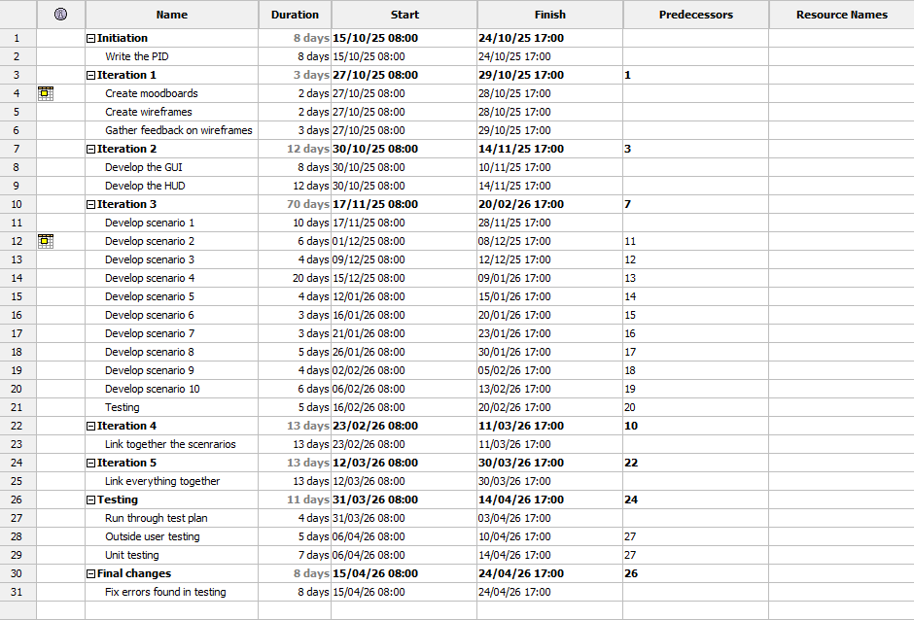
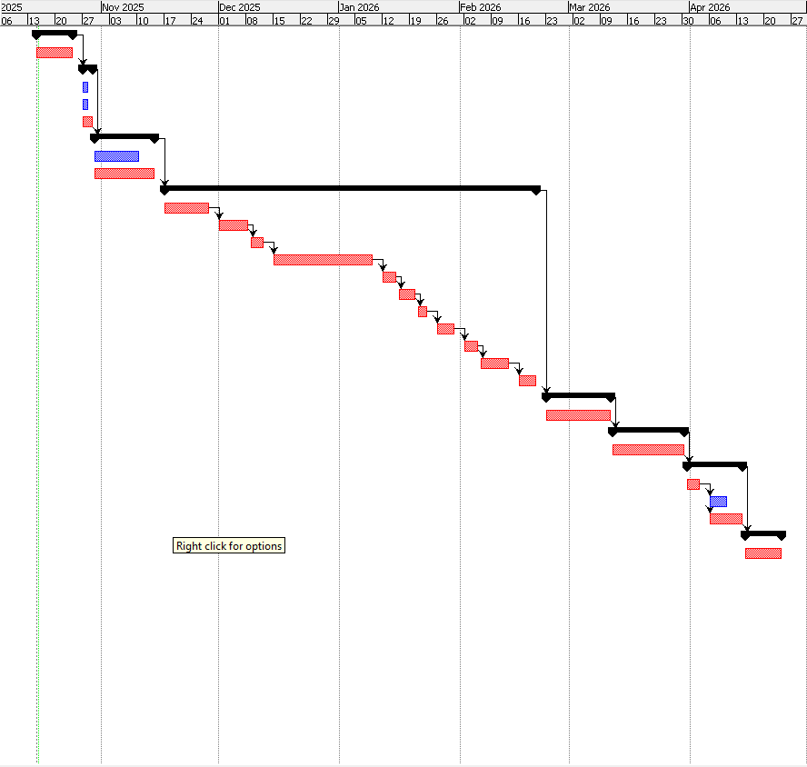

References
Briscoe, J., 2025. We Trained 3 Million Employees: How Effective Is Security Awareness Training?. [Online]
Available at: https://hoxhunt.com/blog/how-effective-is-security-awareness-training#:~:text=%E2%80%8D-,How%20effective%20is%20security%20awareness%20training?,%E2%80%8D
[Accessed 20 10 2025].
CarlJ, 2025. 80% Fewer Clicks: The Power of Cyber Security Training. [Online]
Available at: https://pro-networks.co.uk/blog/cyber-security/80-fewer-clicks-power-cyber-security-training#:~:text=The%20Bottom%20Line:%20Training%20Works,remains%20effective%20against%20evolving%20threats.
[Accessed 20 10 2025].
SUNNYVALE, C., 2024. Fortinet Report Finds Nearly 70% of Organizations Say Their Employees Lack Fundamental Security Awareness. [Online]
Available at: https://www.fortinet.com/corporate/about-us/newsroom/press-releases/2024/fortinet-report-finds-70-percent-of-organizations-lack-fundamental-security-awareness-for-employees#:~:text=Most%20organizations%20are%20motivated%20to,three%20hours%20as%20the%20ave
[Accessed 20 10 2025].
Team, V., 2025. 207 Cybersecurity Stats and Facts for 2025. [Online]
Available at: https://www.vikingcloud.com/blog/cybersecurity-statistics#:~:text=Up%20to%2098%25%20of%20cyberattacks,for%20across%20the%20next%20year.
[Accessed 20 October 2025].

